Analog ASIC

# Pros

1. IP protection (impossible to do reverse engineering)
2. Cost when large production
3. Size

# Cons

1. Development time and cost

3 ways to create an analog ASIC, describe below:

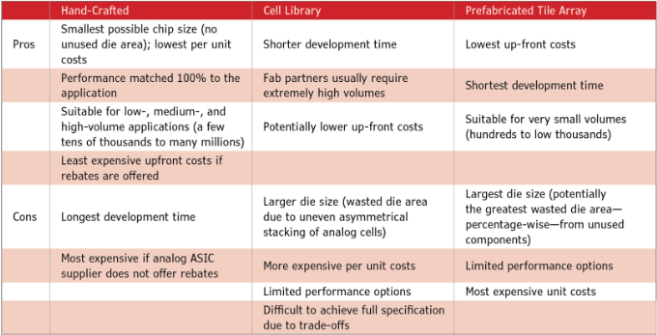

Customs possible???

## Technologies

* Xfab 180n
* ST
* TSMC
* ONSEMI

|  |  |  |
| --- | --- | --- |
|  | Pros | Cons |
| Xfab | * Used at THALES & IMS |  |
| ST | * Strong ressources at IMS | * Hard to use ST at THALES? |
| TSMC |  |  |
| ONSEMI |  |  |

|  |  |  |  |  |
| --- | --- | --- | --- | --- |
|  | Xfab | ST | TSMC | ONSEMI |
| performance |  |  |  |  |
| Catalogue IP |  |  |  |  |
| Export limitation |  |  |  |  |
| Cost |  |  |  |  |

## Cost

1. Conception (soft, time, difficulty…etc.)
2. Fabrication
3. Test

Rentability calculation : [All About Analog ASICs (Part 3) - Circuit Cellar](https://circuitcellar.com/research-design-hub/basics-of-design/all-about-analog-asics-part-3/) IRR calculation

Rebates and

NRE (non recurring engineering): development of customs products or part, tooli, design…etc.

NRE not for off-the-shelf products (produit pret à l’emploi) and standard components.

NRE: [NRE Costs: What You Should Know About Them - Insight Solutions Global](https://insightsolutionsglobal.com/what-is-nre-non-recurring-engineering-cost/)

## Software :

Conception hand-crafted :

Conception from librairies :

## Project :

|  |  |  |  |  |
| --- | --- | --- | --- | --- |
|  | Pros | Cons | Techno possible | ASIC method (libraries, custom) |
| Project n°1 |  |  |  |  |
| Project n°2 |  |  |  |  |
| Project n°3 |  |  |  |  |

## Custom chip

Elements:

1. Accurately identify cost of the current solution (BOM)
2. Ressources (soft …etc.)
3. Estimate correctly the number of product that will be produced and their longevity
4. Analyze risks for both sides, customer and analog ASIC supplier.

To do:

* Clarify points about techno and fill in this document parts with information from IMS part
* When it is done look at projects with THALES
* Estimate price as the page link do above in the document
* Learn analog ASIC competences